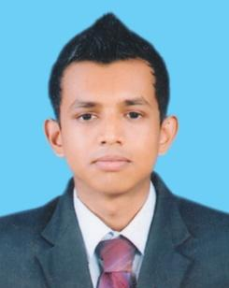



























**I hereby certify that the above information is correct and complete to the best of my knowledge & belief.**

……………………………. ………………..……………

Date R.C.K Jayarathne.